University Of Engineering and Technology, Lahore
Computer Engineering Department

Course Name: Programming Fundamentals | Course Code: CMPE-112L
Assignment Type: Lab Report | Dated:
Semester: 1st | Session: 2026 Spring
Lab/Project/Assignment #: 4 | CLOs to be covered: CLO
Lab Title: Nested Loop | Teacher Name: Hafiz Muhammad Mubashar
Lab Evaluation:

CLO1 | Apply appropriate programming techniques to create executable programs to solve well defined problems
 | Level1 | Level2 | Level3 | Level4 | Level5 | Level6
(5)
Total |  |  |  |  |  | /5
Rubrics for Current Lab Evaluation
Scale | Marks | Level | Rubric
Excellent | 5 | L1 | Submitted all lab tasks, BONUS task, have good understanding.
Very Good | 4 | L2 | Submitted the lab tasks but have good understanding
Good | 3 | L3 | Submitted the lab tasks but have weak understanding.
Basic | 2 | L4 | Submitted the lab tasks but have no understanding.
Barely Acceptable | 1 | L5 | Submitted only one lab task.
Not Acceptable | 0 | L6 | Did not attempt
LAB No 1
Lab Goals/Objectives:
• Understand the concept of Nested loops.
• Learn to repeat tasks using loops.

Equipment Required:
• Computer/Laptop
• Python 3.x
• IDE (IDLE, VS Code, or PyCharm)

Theory:

A nested loop is a loop placed inside another loop. The inner loop executes completely for each iteration of the outer loop. Nested loops are commonly used for creating patterns, working with tables, and processing two-dimensional data.

Lab Work:

Nested Loop:

Task 1:

for i in range (1,5):
for j in range (3):
print(i,j)

Result:

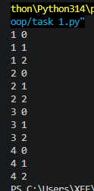

Task 2
for i in range (1,5):
for j in range (1):
print(i,j)

Result:

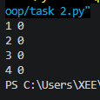

Task 3:
for i in range (1,5):
for j in range (i):
print("*",end="")
print()

Result:

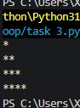

Task 4:
for i in range (1,5):
for j in range (i):
print("i=",i,"j=",j)
print(".....")

Result:

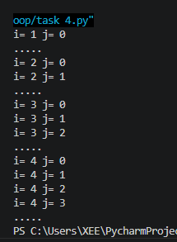

Task 5:

for i in range (1,5):
for j in range (i):
print("(",i,",",j,")",end="")
print()

Result:

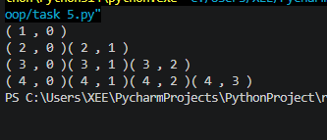

Task 6:

for i in range (1,5):
for j in range (1,1+i):
print(i,end=" ")
print()

Result:
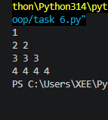

Task 7:

for i in range (1,5):
for j in range (5-i):
print("*",end=" ")
print()

Result:

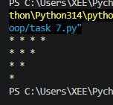

Task 8:

for i in range (1,5):
for j in range (5-i):
print("1",end=" ")
for j in range(i):
print("*",end=" ")
print()

Result:

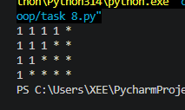

Task 9:
for i in range (1,5):
for j in range (5-i):
print(" ",end=" ")
for j in range(i*2-1):
print("*",end=" ")
print()
Result:
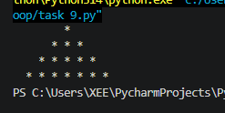

Task 10:

i=1
while i <= 5:
j=0
while(j<=5-i):
print(" ", end=" ")
j=j+1
while (j<(i*2)-1):
print("*", end=" ")
j=j+1
print()
i=i+1

Result:
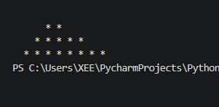

Task 11:

i=1
while i <= 4:
j=0
while(j<=4-i):
print(" ", end=" ")
j=j+1
j=0
while j<(2*i)-1:
print("*", end=" ")
j=j+1
print( )
i=i+1

Result:

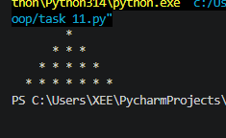

Conclusions:

In this lab, we learned how nested loops work and how they can be used to solve complex repetitive tasks. We also practiced creating patterns and improving programming logic using nested loops.

